Monthly District 11 GSR Meeting – MAY 2017
ALL AA MEMBERS ARE WELCOME!
May 30th at 7:00 pm at the Franklin Baptist Church, 21 Church St., Franklin
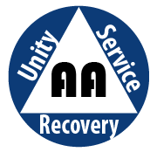
Entrance and parking at rear of church on School St.

Extra parking available in municipal lot next to church

